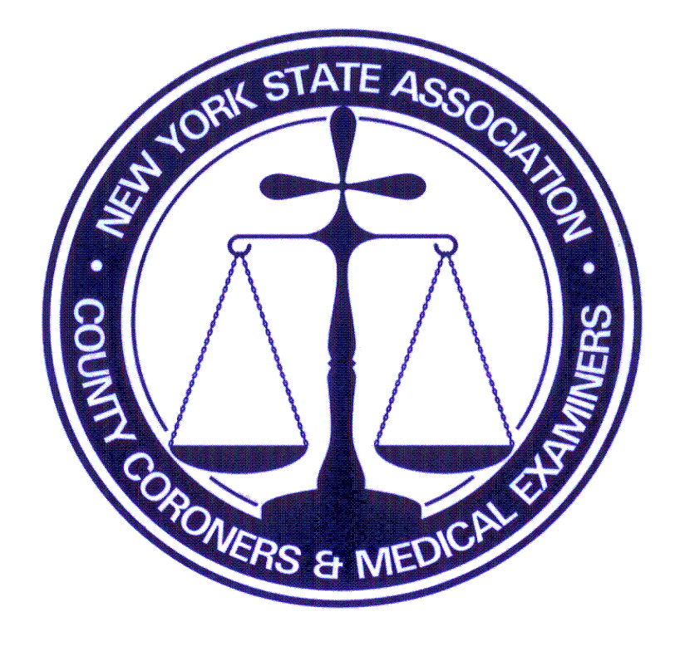
NYSACCME
Fall
Friday, September 29 –
Sunday, October 1, 2023
Lake Ontario Conference
Oswego, NY 13126

6179 Middle Rd. Munnsville, New York 13409
Telephone (315)750-6997
www.nysaccme.org tgreenwood@nysaccme.org

EXHIBIT BOOTH REGISTRATION FORM

Name ____________________________________Title _______________________________________
Address __________________________________ Telephone __________________________________
City________________________ State ________________ Zip Code ___________________________
E-Mail Address _______________________________________________________________________
Representing (Organization)______________________________________________________________

RESERVATIONS AND PAYMENTS ARE MADE THROUGH THE NYSACCME OFFICE
AND MUST BE RECEIVED and POST MARKED NO LATER THAN September 8, 2023

Exhibit Booth Fee - 1 table, 2 chairs (fee varies according to space needed) $ _300.00_
****If exhibitor is a conference sponsor* for a minimum of $500, the Exhibit Booth Fee is waived.

*If your organization is a conference sponsor, please indicate what area,
i.e. Breakfasts, Breaks, Hospitality Suite, Cocktail Hour, etc. _____________________
and enter amount of sponsorship $ ________
□ Please “x” here to acknowledge that your organization will be making arrangements
directly with the hotel if you are sponsoring the Cocktail Hour or After-Dinner Social.

IF EXHIBITOR IS NOT ATTENDING CONFERENCE SESSIONS, FILL IN APPROPRIATE BOX:
Package 1: $ 500.00_
- Friday and Saturday night lodging
- Saturday breakfast, breaks, lunch, dinner
- Sunday breakfast, break
If applicable: Spouse/guest weekend meal package: $175 $ ________
Spouse/guest Saturday dinner only: $50 $ ________
AMOUNT DUE (CHECK or MONEY ORDER PAYABLE TO: NYSACCME) $ ________

Package 2: $ _300.00_
- Saturday night lodging
- Saturday breakfast, breaks, lunch, dinner
- Sunday breakfast, break
If applicable: Spouse/guest weekend meal package: $175 $ ________
Spouse/guest Saturday dinner only: $50 $ ________
AMOUNT DUE (CHECK or MONEY ORDER PAYABLE TO: NYSACCME) $ ________

Package 3: $ 200.00
- No lodging (commuter)
- Saturday breakfast, breaks, lunch, dinner
- Sunday breakfast, break
If applicable: Spouse/guest weekend meal package: $175 $ ________
Spouse/guest Saturday dinner only: $50 $ ________
AMOUNT DUE (CHECK or MONEY ORDER PAYABLE TO: NYSACCME) $ ________

Page 1 of 2 See Page 2 for Conference Registration

IF EXHIBITOR IS ATTENDING CONFERENCE SESSIONS, FILL IN APPROPRIATE BOX:
Package 1: NYSACCME MEMBER: $600 NON-MEMBER: $700 $ ________
- Friday and Saturday night lodging
- Saturday breakfast, breaks, lunch, dinner
- Sunday breakfast, break
If applicable: Spouse/guest weekend meal package: $175 $ ________
Spouse/guest Saturday dinner only: $50 $ ________
AMOUNT DUE (CHECK or MONEY ORDER PAYABLE TO: NYSACCME) $ ________

Package 2: NYSACCME MEMBER: $450 NON-MEMBER: $550 $ ________
- Saturday night lodging
- Saturday breakfast, breaks, lunch, dinner
- Sunday breakfast, break
If applicable: Spouse/guest weekend meal package: $175 $ ________
Spouse/guest Saturday dinner only: $50 $ ________
AMOUNT DUE (CHECK or MONEY ORDER PAYABLE TO: NYSACCME) $ ________

Package 3: NYSACCME MEMBER: $300 NON-MEMBER: $ $ ________
- No lodging (commuter)
- Saturday breakfast, breaks, lunch, dinner
- Sunday breakfast, break
If applicable: Spouse/guest weekend meal package: $175 $ ________
Spouse/guest Saturday dinner only: $50 $ ________
AMOUNT DUE (CHECK or MONEY ORDER PAYABLE TO: NYSACCME) $ ________

$25 Service Charge will apply for checks returned for insufficient funds

(NON-REFUNDABLE FEE: Member-$100 / Non-Member-$200)

CANCELLATIONS MUST BE DONE THROUGH THE NYSACCME OFFICE.
THERE WILL BE CANCELLATION CHARGES FOR ROOM
RESERVATIONS CANCELLED WITH LESS THAN 48 HOUR NOTICE
AND MEAL PACKAGE WITH LESS THAN A WEEK PRIOR TO CONFERENCE.

I have read and agreed to the terms specified above:___________________________________
Registrant’s Signature
FOR OFFICE USE ONLY
Total paid $______________ Check Number ____________

2/12/23tg

Page 2 of 2

